

UCLA Semel Institute
INSERT FELLOWSHIP NAME

Faculty Supervisors
Name (Title, Primary Supervisor)
Email:

Name (Title, Supervisor)
Email:

Name (Title, Supervisor)
Email:

Table of Contents

Postdoctoral fellow minimum qualifications 3
Application Process: 3
Special Note 3
Program Overview 3
UCLA Ronald Reagan Medical Center 3
Training Goals and Objectives 4
Supervision 4
Evaluating and Monitoring of Performance 4
Due Process and Grievance Procedures 5
SOFI Reporting 5
Mistreatment and Non-Discrimination Policies 6

Postdoctoral fellow minimum qualifications
Applicants are required to have completed their training in an APA or CPA accredited PhD or PsyD program in Clinical, Counseling, or School Psychology. Applicants are required to have completed an APA-accredited internship or one that meets APPIC standards (training brochure required to submit with application if internship was not APA accredited). Candidates should have specific training experience in clinical health psychology in order to be able to benefit from the experiences offered during the fellowship year. UCLA Clinical Psychology Training Programs are committed to the recruitment of culturally and ethnically diverse individuals. Candidates from minority and diverse cultural backgrounds are encouraged to apply.

Application Process:
Application Procedures: Interested candidates should submit the following materials:
- A cover letter detailing professional interests, training and experiences.
- A current Curriculum Vitae (CV)
- Three letters of recommendation, with one preferably being written by a direct internship supervisor.
- Two de-identified writing samples (e.g., inpatient consult report, outpatient diagnostic interview). Please make sure that at least one writing sample has a case conceptualization.
Please direct application materials or any questions to (name) by email at (email)

Special Note
Start dates for the 2024-2025 training year must be between 08/15/2024 – 09/15/2024. These start dates provide ample time to receive the required degree verification before trainee begins their program at UCLA.

Program Overview
Training Program Description

UCLA Ronald Reagan Medical Center
The UCLA Ronald Reagan Medical Center is located on the Westwood, Los Angeles Campus. UCLA Ronald Reagan Medical Center is a world-renowned premier institution at the forefront of healthcare excellence. With a rich history of innovation, compassionate care, and groundbreaking research, our medical center is dedicated to advancing the health and well-being of individuals locally, nationally, and globally.
Comprising state-of-the-art facilities, cutting-edge technology, and a multidisciplinary team of world-class physicians, nurses, and healthcare professionals, the UCLA Ronald Reagan Medical Center offers comprehensive medical services across a vast array of specialties. From primary care to complex surgeries, from advanced diagnostics to rehabilitation, our institution delivers personalized, patient-centered care that prioritizes both medical expertise and individual needs.

Training Goals and Objectives
- Please describe the training goals and objectives for this fellowship

Supervision
Fellows will receive supervision that meets the California Board of Psychology requirements for licensure. Supervised professional experience often exceeds the state’s licensure requirement of 1,500 post-doctoral hours and includes 2 hours per week of individual supervision with two separate licensed supervisors and approximately 2.5 hours per week of group supervision. Postdoctoral fellows will also receive supervision of supervision, as they take on their own supervisees, by supervising psychology interns in their clinical and testing cases. The nature of the supervision will be direct observation, case review/discussion, and at times co-treatment with a supervisor (e.g., seeing patients together in a primary care setting). Supervision at each rotation will begin with direct observation and will evolve into case review and discussion as the fellow demonstrates greater levels of development across competencies.

Evaluating and Monitoring of Performance
At the initiation of the fellowship, the fellow and their primary supervisor will identify individualized training goals and objectives. Fellows will receive feedback weekly at their individual supervision sessions. Clinical and professional competency will be measured 3-timesper-year, through a written professional competency form (provided through Medhub) which assesses the 9 APA defined competencies (i.e., Research, Ethical and Legal Standards, Individual and Cultural Diversity, Professional Values, Attitudes, and Behaviors, Communication and Interpersonal Skills, Assessment, Intervention, Supervision, and Consultation and Interprofessional/Interdisciplinary Skills). The form will be completed by the Fellows’ supervisors. Feedback will be based on supervisors’ observations of Fellow, review of documentation (e.g., clinical notes, psychological assessments), and review of supervisees’ evaluations of supervision.

Due Process and Grievance Procedures

Clinical Postdoctoral Fellows in our programs have available due process and grievance procedures under the aegis of the administrative entity at UCLA in which they are hired. For our clinical emphasis tracks, Fellows are hired, and their positions are administered within the Semel Institute’s Office of Education. The key elements of these policies are summarized below.
It is anticipated that most difficulties can be resolved by Fellows in conjunction with their primary preceptor. In cases where this is considered problematic, or if the Fellow feels there may be a conflict of interest, the next step for Fellows is to contact the director of the training program. Depending on the nature of the problem, the training director may raise issues with the training committee absent the primary preceptor. In cases where the Fellow feels the training director cannot or should not be involved in addressing grievances, the Fellow may address concerns with the Vice Chair for Education in the Department of Psychiatry & Biobehavioral Sciences, and/or Chief Academic Administrative Officer of Department/Institute
Regardless of the hiring unit, UCLA policies indicate that disciplinary actions, including possible probation, non-renewal of appointment, suspension or dismissal, are initiated by written notices to the trainee, indicating the proposed action and the rationale for that action.

SOFI Reporting

Automatically launch SOFI from CareConnect via the new SOFI button

Enter patient-related safety events (Note: Visitor, employee, and DEM events need to be entered through the main SOFI reporting website at sofi.ucla.edu)

Automatically populate the patient demographic information from the patient’s chart you have open in CareConnect.

Automatically populate reporter information based on your CareConnect login. (Note: Anonymous reporting is available through the main SOFI reporting website at sofi.ucla.edu)

Chart Activity – SOFI Button
- Open the patient’s chart to the Chart activity.
- From the Notes tab, click the SOFI button to launch the SOFI (RLDatix) application.
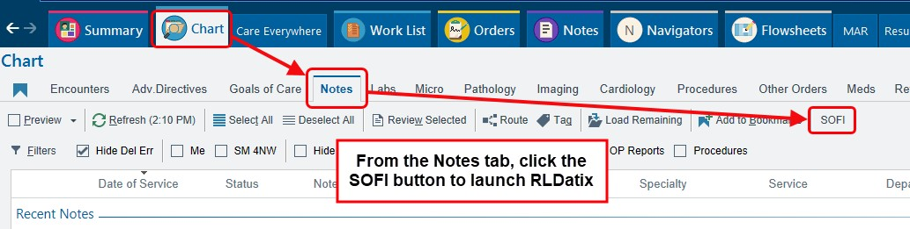
3. Select the Region and Facility the Safety Event occurred, and click Continue.
4. Complete appropriate documentation on the Safety Event Entry form (right sidebar).
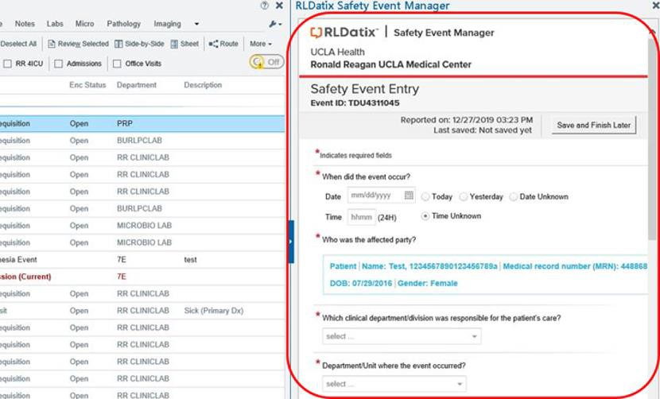
Note that this SOFI report does not flow into the patient’s chart. It is simply a faster way of launching the SOFI application. For any questions regarding SOFI, please contact SOFI@mednet.ucla.edu.

Mistreatment and Non-Discrimination Policies

We value a workplace environment free of discrimination and harassment. Fellows with any concerns related to discrimination, bias, harassment, or violence may contact Dr. Bilder, at any time. There are a number of policies in place to address issues of discrimination, bias, and violence in the workplace.

Community Expectations: Responding to Discrimination in the Clinical and Research Settings
The purpose of this document is two-fold:
First, to describe the shared expectations for the members of our Psychiatry communities for responding to discrimination (including faculty, staff, residents, fellows, postdoctoral- internship- and practicum-trainees, other students, and volunteers), across settings (both clinical and research) both on campus and at affiliated educational/clinical sites outside of UCLA Health.

Second, to guide an appropriate response to reporting and remediating discriminatory or harassing conduct directed towards community members, patients, or research participants (their family members, visitors, or patient representatives) based on those individuals’ protected characteristics, as it pertains to education, training, employment, and patient care.

These expectations apply to all forms of discrimination and provide a template to help guide personnel in both managing discriminatory or harassing behavior, and requests from discriminatory patients/participants for provider/personnel reassignments.

These expectations do not supersede, but rather supplement, existing departmental, hospital, and other University policies that pertain to responding and reporting of incidents of discrimination based on an individual’s protected characteristics.

Mistreatment Incident Reporting
One of the most important priorities at the David Geffen School of Medicine at UCLA (DGSOM) is to provide trainees with the very highest quality clinical learning experiences. Mistreatment of trainees is unacceptable and inconsistent with the commitment to zero tolerance for mistreatment of any kind, and of any form of retaliation against those who report mistreatment. Given the complex nature of our training programs, we understand the importance of having a reporting mechanism for confidential or anonymous trainee complaints of mistreatment. Therefore, the medical student Committee on Learning Environment Oversight (CLEO) and the Mistreatment Incident Reporting Form (MIRF) has been expanded to all trainees, including our GME.

What is GME CLEO and the MIRF?
GME CLEO is charged with being responsible for the review of trainee concerns regarding the learning environment and the development of action plans in response to episodes of alleged mistreatment and to prevent future occurrences. The Mistreatment Incident Reporting Form (MIRF) is an avenue for trainees to submit incidents of mistreatment that they have either personally experienced or heard/witnessed of other trainees. Reporters have the option of submitting incidents either confidentially or anonymously. By submitting confidentially, the reporter may be contacted by the CLEO Chairs and receive updates on the case. By submitting anonymously, the reporter will not be contacted but are able to track the status on the MIRF Status Dashboard.

What happens after I file a MIRF? All MIRFs are reviewed within 72 hours of submission by the CLEO Chairs and staff member. When warranted, the CLEO Chairs may refer a MIRF to Title IX or Discrimination Prevention Office (DPO) for review. CLEO members review MIRFs on a monthly basis at their meetings, MIRFs presented at meetings are redacted of any identifying information for both the reporter and the individual being reported. The committee is composed of faculty, trainees and administration. When reviewing MIRFs, each case has a recommended action plan developed, which is then executed by the CLEO Chairs.

How will this impact my learning environment? In addition to reviewing and triaging MIRFs, the committee is charged with maintaining and analyzing data regarding the learning environment. Databases are kept at the level of each CLEO (UME, GME and Research). By sharing databases, the committees are able to observe for trends across learning environments for all trainees and respond accordingly. Data collected will be routinely shared with various stakeholders to address any concerns.

How do I access the MIRF? Please refer to the following website: https://uclahs.fyi/MIRF

